OneToMany Bidirectional

An Instructor can have Many Courses

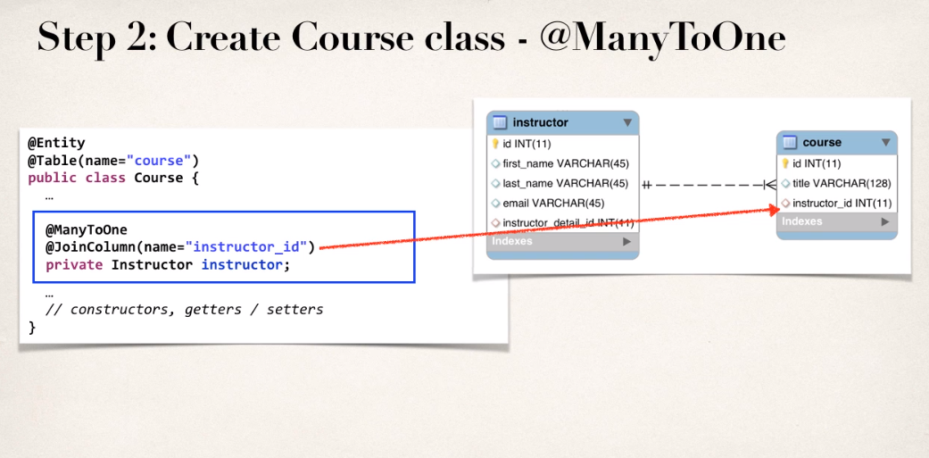

Add OneToMany property and map it to the “instructor” variable to the Course class

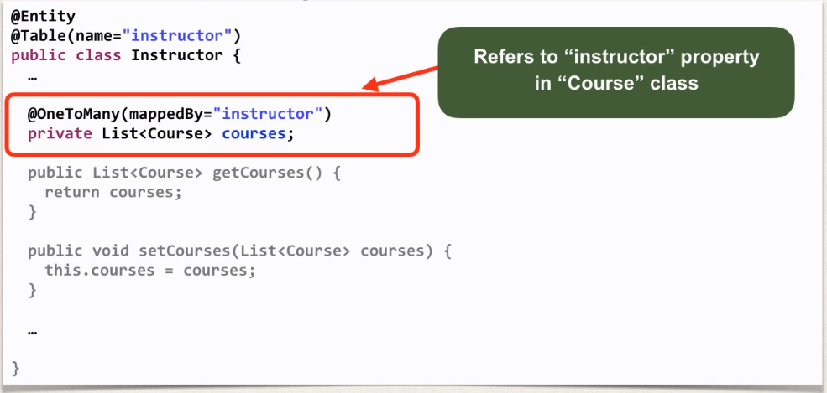

More on mappedBy

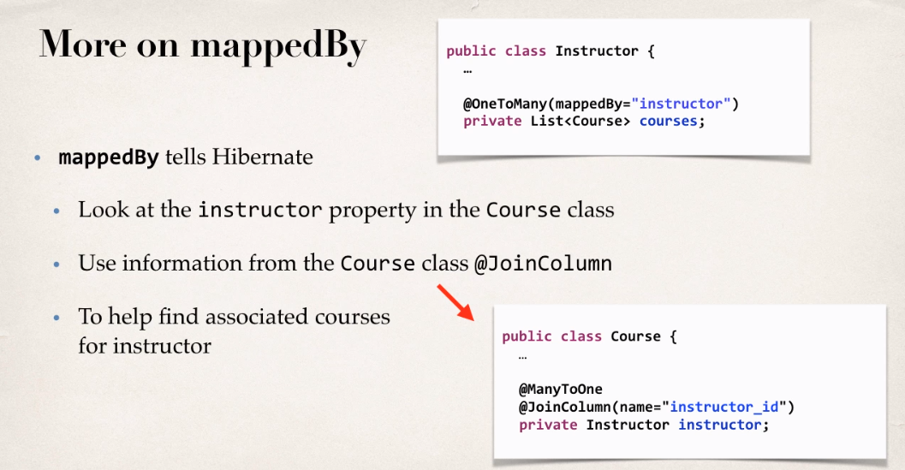

Add Cascading so if we delete Instructor it won’t delete Courses associate with it.

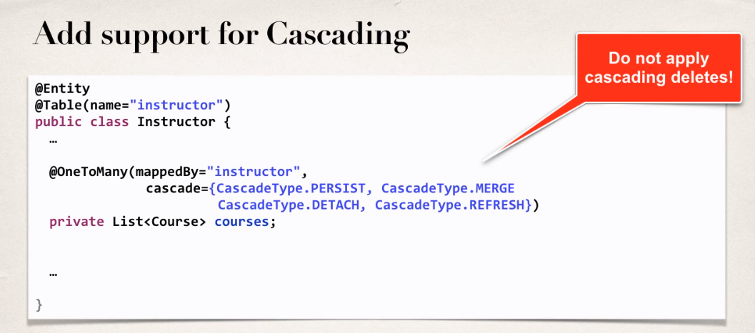

Add Cascading so if we delete Course then it won’t delete associated Instructor.

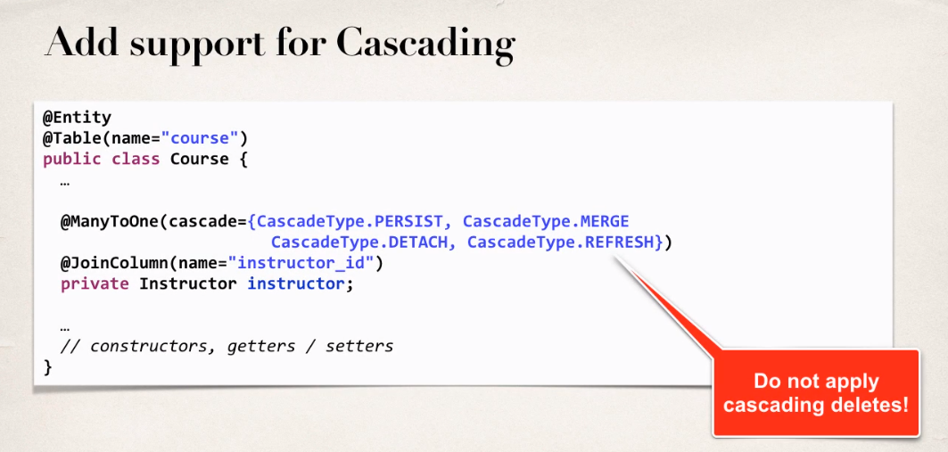

Course.java

Note: JoinColumn name= (name of the reference column in the table)

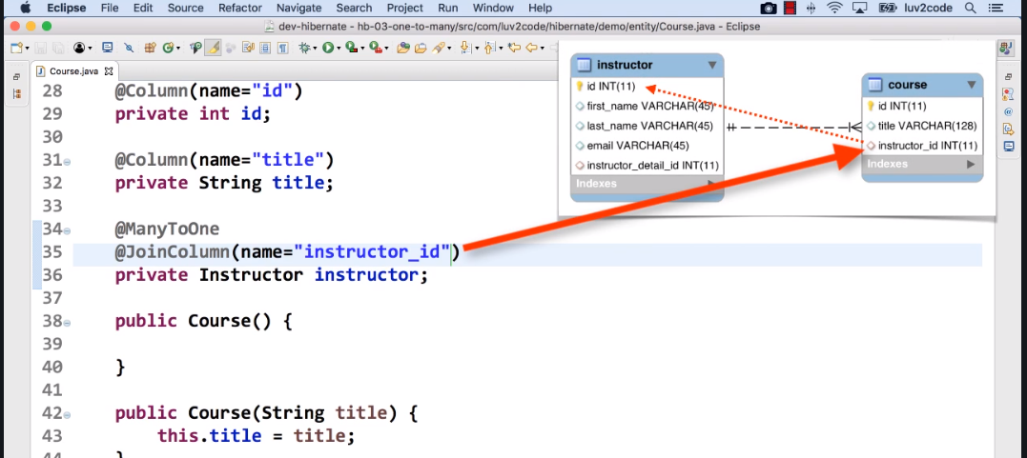

Instructor.java

